(1 mark, file to be edited: Q5.c)
Your program allows users to enter array of n integers, where n is entered by the user (n < 10).
If all elements of the array are even numbers, the program displays to screen: “Even array of n elements” where “n” is the number of elements in the array.
Else, the program displays to screen: “Not even array of n elements” where “n” is the number of elements in the array.
Below are examples.
n = 5, array = [7, 1, 4, 9, 2]  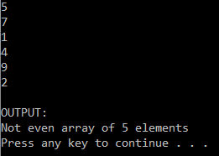 | n = 5, array = [2, 2, 4, 8, 10]  